Drimnin Community Broadband – Troubleshooting guide.
The equipment names. Please familiarise yourself with these names otherwise it can be difficult to assist you to find the problem
The Router Front view  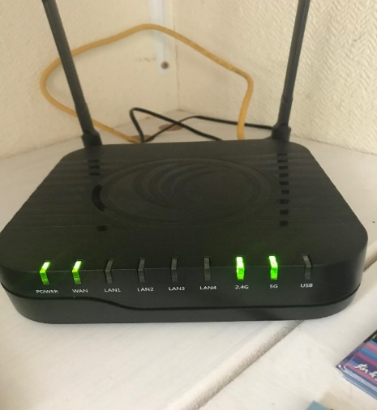with correct lights showing | The Router Rear view  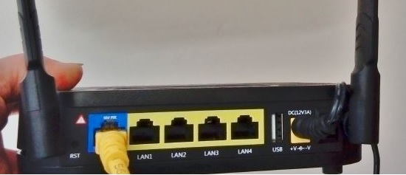  with yellow cable plugged into the WAN port
The AC power adapter 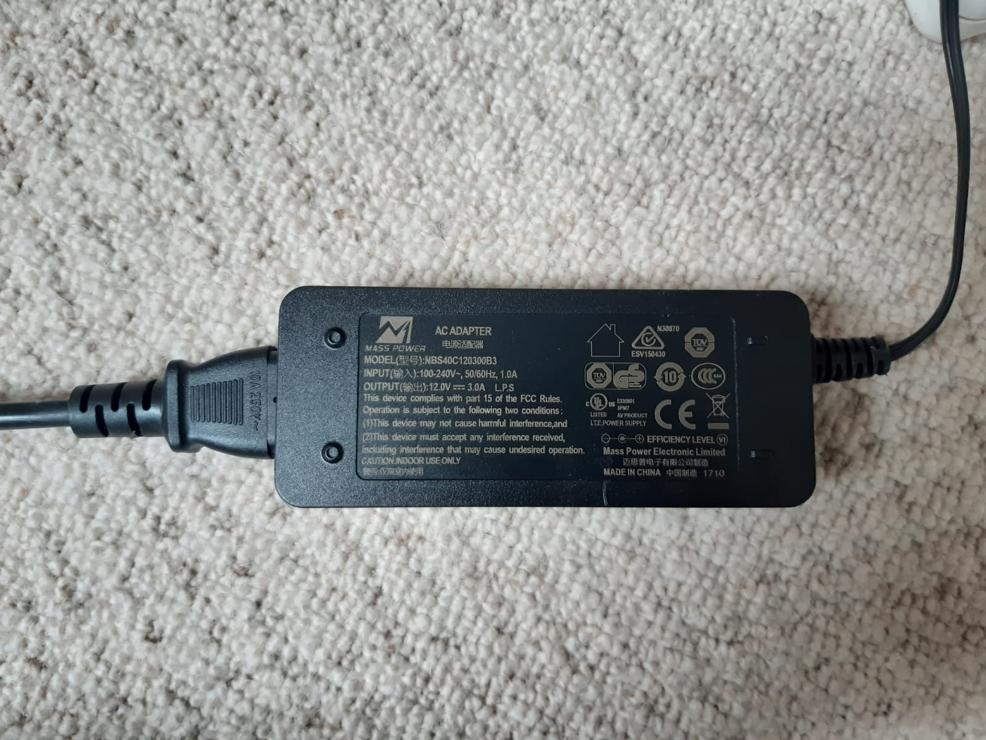This should be plugged into a power socket and into the back of the router | The PoE  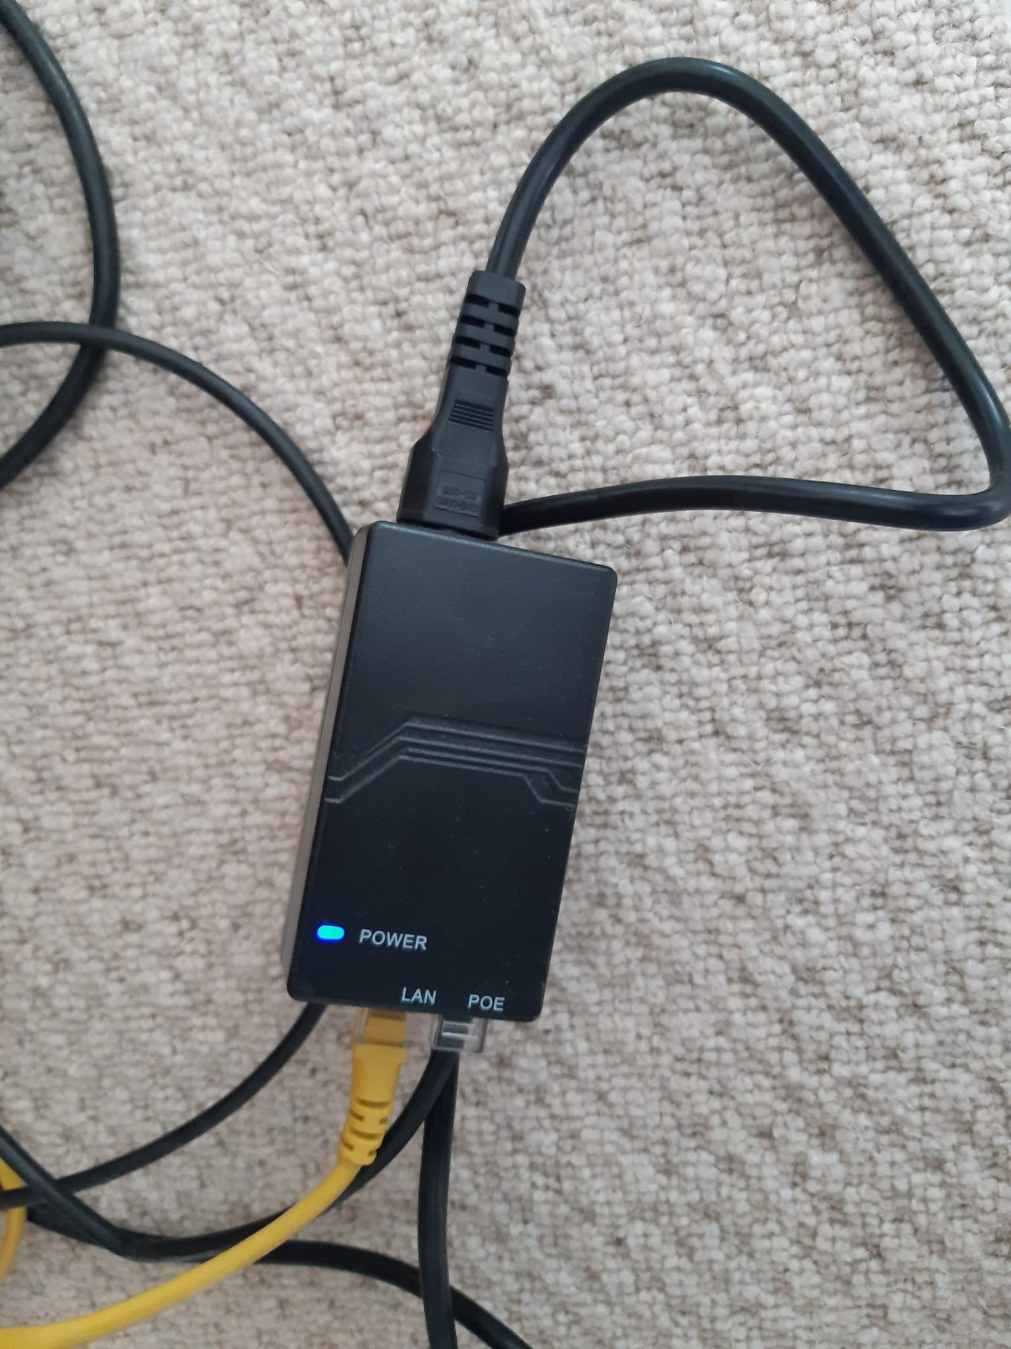  This should be plugged into a power socket with a power light showing  Yellow cable plugged into LAN  Black cable plugged into Poe port

For your consideration:
Drimnin Community Broadband is a community service which due to its geographical spread is run and supported in the various locations, by volunteers who also have regular day jobs. We can call on the assistance of our technical support team (Rapier), but this is very costly.

Your help in checking your equipment in the event of a fault is therefore invaluable to us as our volunteers have to fit in ‘call outs’ in and around their normal working hours.

DCB reserves the right to levy a ‘call out’ fee to cover time and materials for the repair or replacement of damaged equipment.

Thank you for your continuing support.

If your connection stops working
If possible, please ensure that you have tried more than one device (e.g., a phone and a laptop). If you have a connection on one device it is not the broadband that has failed but may be an extender or other personal device. In this case, although we may be able to offer advice, you may need to contact the manufacture of your device or Wi-Fi Extender.

First Checks: Your home equipment (computer, extender, phone, TV, printer):
- Reboot (turn off/on again) your PC/tablet/phone.
- Make sure your device’s Wi-fi is pointing to the router:-
  - Either via wireless Wi-Fi service (eg. CAMBIAN_2.4GHz_141BC8),
- Or via a physical Ethernet Network cable and plugged into a yellow ‘LAN’ Port (nos. 1 – 4). If using Ethernet Network cable check both ends are securely plugged into their ‘ports’.
- Please remember that it may be a problem with your extender rather than the incoming broadband or the DCB Router. Therefore, reboot any extenders that you use to boost the signal around your property. If this fails to correct the problem please try to connect your device directly to the DCB router either via Wi-fi or ethernet cable, missing out your extender. Please note you may have to physically move the item nearer to the router if the extender was used to reach the device in the first place.
- DCB cannot help directly if the fault is with your computer equipment or other devices such as extenders, phones, TVs.

Second Checks: DCB (our) Equipment:

- Reboot (turn off/on again, leaving off for 5 seconds) the power to your router and the POE unit
- Are both the Wi-Fi Router and POE adapter plugged in
- Check that both Router and PoE have LED lights illuminated? Remember somebody in your household may have unplugged it by mistake (visiting family etc)
- If no light showing please test that all of the household power sockets that you are using have power (by plugging in a light to each power socket, including all sockets in any extension leads that you are using, just one socket can fail)
- If the power socket is working but you still have no power lights on the router or the poe please replace the fuse in the plug, if you cannot do this yourself please ask someone for assistance or email Drimnin Community Broadband via your phone or a friend or neighbour with internet – drimnincommunitybroadband@gmail.com.
- Yellow Cable must connect Wi-Fi Router (blue WAN port) into POE adapter.
- Is the network connection showing on the Wi-Fi Router? (Green LED labelled ‘WAN’).
- Please check that all the cables are plugged into their ports properly and the cables both internally and on the outside of your property are undamaged.
- Visually check to make sure that the Nano ‘aerial’ (fixed on the outside of your premises) has not been damaged, or moved, and it is pointing in the direction of the transmitter on Mull.
- Make sure there is nothing blocking the line of sight between you and the transmitter on Mull (i.e. fallen trees, vehicles etc.).
- Are you aware of any work that has been done by tradesmen, etc. who may have inadvertently moved or damaged the equipment? (i.e. cable/dish/aerial damage).
- Has there been a power cut? If so it can take some time for the whole network to come back online.
- Check with a neighbour to see if they are having the same problem.

Be aware that due to the nature of the network it might be that the power cut is in a different area from yourself but affecting a relay which provides the signal to you.

DO NOT ‘RESET’ THE CAMBIAN Wi-Fi ROUTER OR POE ADAPTER.
Resetting the equipment defaults it to factory settings which will require our team to
re-install the configurations. Meanwhile you will no longer be able to connect to our service.

If none of the above actions resolve your problem and you still cannot connect to the Internet then please contact DCB:-

- If you have internet access via your phone, a friend or neighbour email:
  - drimnincommunitybroadband@gmail.com

