Drimnin Community Broadband – Start up and Troubleshooting guide.
Please print this guide and keep it for reference by the Cambian Wi-Fi Router.
Getting Connected
Once your order has been placed and the equipment installed you will be advised when it is “live”. There may be a delay whilst your equipment is configured correctly. You will be informed when all is setup ok – and the wireless ‘Cambian Wi-Fi Router’ should have x4 green LED lights on (see photo below).
There are two pieces of equipment – and both MUST be plugged in and turned on! They are connected together via a yellow cable which must be plugged into the blue ‘WAN’ port on the Cambian Wi-Fi Router. (see photos below)
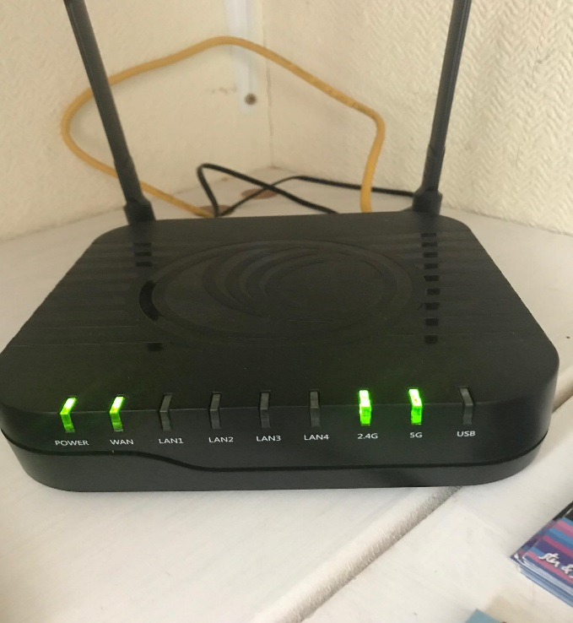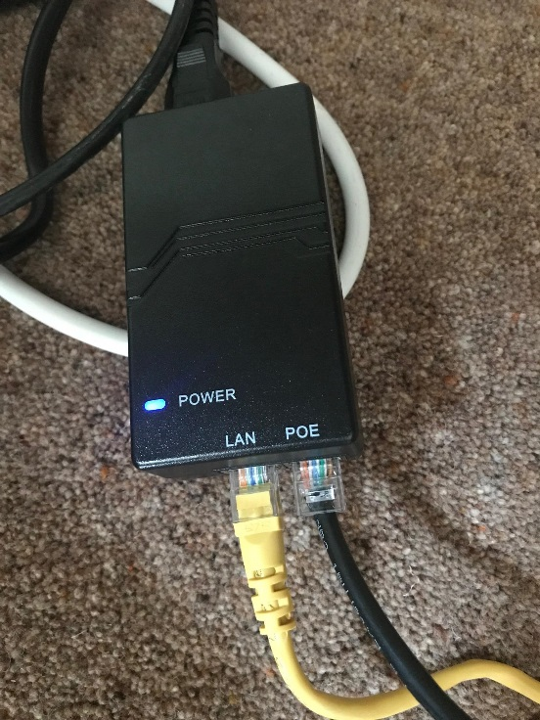
Cambian Wi-Fi Router – correct lights.  (with separate AC adapter) | POE adapter

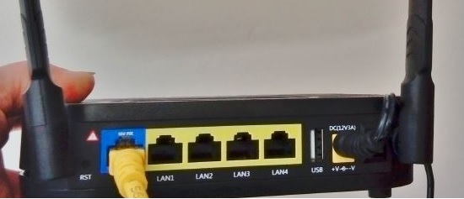
Cambian Wi-Fi Router – rear view of LAN Ports.
If you are unable to connect to the internet please follow the instructions below before contacting us for assistance. In the event that you call us first you will be asked to do the following so it would save time if you have all the relevant information when contacting us.
Making the Connection
There are 2 ways to connect to the network:-
- Wired connection - where your device (Eg. Computer, TV etc.) is connected via an Ethernet cable directly into the Cambian Router. This is best for desktop PCs, TVs or for use with a VOIP (Voice Over Internet Protocol) telephone service. It does not need a password.
- Plug an Ethernet cable (NOT supplied by DCB) directly into any one of the yellow sockets (called Ethernet Ports) number 1 to 4 on the back of the Cambian Router. Connect the other end to the Ethernet port on your computer, VoIP phone or TV. (There should be a flashing LED light on your computer next to the Ethernet port – showing it is working. If no light – it could be a problem with the cable).
- Wireless connection - which uses Wi-fi, is slightly slower, but ideal for portable devices such as laptops, tablets, and smartphones.
- The new DCB Wireless name should appear as CAMBIAN_2.4GHz_141BC8 (or similar) and the password was given to you when the equipment was installed.
- Follow the wireless connection instructions for your device and enter the password (also known as a secure network key, or WPA) when requested. The router has two radio signals (2.4Ghz and 5Ghz) - so enter the password in both if your device can see both of them.

We suggest you select the 5GHz network first. If you find this doesn’t reach as far as you need, try switching to the other frequency.
You will need to connect any devices which use the internet or your home network (laptops, tablets, phones, TVs, devices controlled by phone apps etc.) to the new router.

Thank you for your continuing support.

